Project Development Phase
Model Performance Test

Date | 08 September 2026
Team ID | SWUID2026190415
Project Name | Medical Diagnosis Center by Service Portal (ServiceNow)
Maximum Marks | 4 Marks

Model Performance Testing:
Project team shall fill the following information in model performance testing template.
S.No. | Parameter | Values | Screenshot
 | Model Summary | Not Applicable (N/A).  This project is developed on the ServiceNow platform as a Service Portal application. It uses Business Rules, Flow Designer, Service Portal Widgets, Notifications, and Custom Tables. No Artificial Intelligence or Machine Learning model is used in this project. | 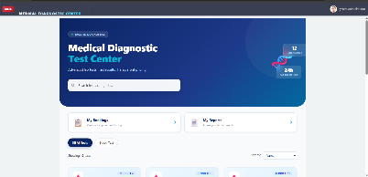
 | Accuracy | Not Applicable (N/A).  No machine learning model is trained in this application.
 | Validation Accuracy | Not Applicable (N/A).  The application functionality is validated through ServiceNow testing instead of model validation. | 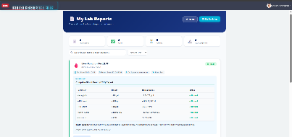  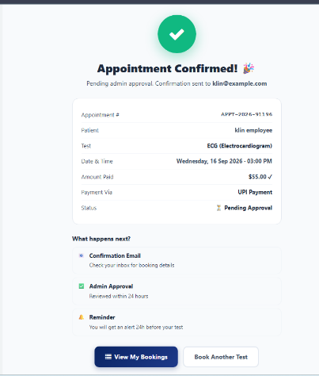
4. | Fine Tunning Result( if Done) | Not Applicable (N/A).  Fine-tuning is not required because this project does not use an AI model.

